CSA0911 – JAVA PROGRAMMING
COMMON COURSE ASSIGNMENT FORMAT
SMART HOSPITAL PATIENT APPOINTMENT, PHARMACY INVENTORY AND ALERT NOTIFICATION SYSTEM

Attaluri Sri Vamsi (192372242)
P.V.S.Pradeep Reddy(192311364)
B.Hemanth Kumar(192324238)
A. Assignment Information
Particular | Details
Department: | Computer Science and Engineering (Artificial Intelligence)
Programme: | B.E.
Course Code & Course Name | CSA0911 - Programming in Java
Academic Year / Batch | 2023-2027
Faculty Name | Dr.R.Thalapathi Rajasekaran
Assignment Title | Hospital Management System using Java OOP, Collections, Exception Handling and Multithreading
Date of Issue | 01-September -2026
Date of Submission | 02-September-2026
Maximum Marks | 100
Course Outcome(s) - CO | CO1: Apply OOP principles in Java.  CO2: Implement Java Collections & Iterators.  CO3: Develop robust applications using custom exceptions.  CO4: Design concurrent multithreaded systems with thread synchronization.
Bloom's Taxonomy Level | Level 3 (Apply), Level 4 (Analyze), Level 5 (Evaluate), Level 6 (Create)
SDG Mapping (SDG 1-17) | SDG 3: Good Health and Well-being  SDG 9: Industry, Innovation, and Infrastructure  SDG 10: Reduced Inequalities
Industry / Societal Relevance | Hospital appointment workflows, pharmacy safety, and concurrent race-condition prevention in critical health infrastructure.

1. Problem Statement and Problem Formulation
The Smart Hospital Patient Appointment, Pharmacy Inventory and Alert Notification System is a complete, menu-driven Core Java application designed to manage patient health records, doctor appointment scheduling, pharmacy medicines, inventory levels, and notification activities in an integrated, thread-safe manner.
The system addresses common hospital-management challenges such as registering patients and doctors, displaying records, booking and cancelling appointments, maintaining a fair FIFO waitlist when doctors are fully booked, issuing medicines atomically, restocking supplies, detecting low-stock medicines, generating reports, and dispatching asynchronous notifications.
The problem is formulated as an interconnected collection of domain entities (Person, Patient, Doctor, Appointment, Medicine, Inventory, Notification). Shared state information is protected using private attributes (Encapsulation), abstract base classes define unified contracts (Abstraction), specialized patient categories and medicine types leverage inheritance and method overriding (Polymorphism), Java Collections manage dynamic data with explicit Iterators, custom checked exceptions protect application flow, and multithreading with synchronization locks simulates concurrent bookings and asynchronous alert dispatching.

2. Objective and Expected Outcomes
•Develop a comprehensive menu-driven hospital-management application using Core Java.
•Apply classes, objects, encapsulation, data hiding, inheritance, and runtime polymorphism.
•Use ArrayList, HashMap, LinkedList, and Queue with Java generics for safe record management.
•Explicitly implement Iterator and ListIterator for collection traversal, safe removal, and in-place updates.
•Implement user-defined custom checked exceptions for invalid IDs, duplicate appointments, and out-of-stock conditions.
•Implement multithreading, thread priorities, synchronization, and race-condition prevention.
•Maintain doctor appointment capacity and automatic FIFO waitlist promotion upon appointment cancellation.
•Generate real-time patient visit, appointment status, revenue, and pharmacy inventory reports.
•Dispatch asynchronous appointment reminders and critical low-stock notifications.
•Provide a reliable, crash-resilient console user interface with robust input validation.

3. Requirements, Constraints and Assumptions
3.1 Functional Requirements
•Register, display, search, and update patient records across General, Senior Citizen, and Insured tiers.
•Register and display doctors with specializations and available consultation slots.
•Book and cancel appointments with conflict detection for duplicate date/time slots.
•Automatically place patients onto a doctor's waitlist when consultation slots are occupied.
•Promote the next waitlisted patient to a booked appointment when an existing appointment is cancelled.
•Add, display, dispense, and restock Prescription (Rx) and Over-The-Counter (OTC) medicines.
•Detect medicines at or below the configured low-stock safety threshold (<= 10 units).
•Dispatch polymorphic appointment reminder and low-stock alert notifications in the background.
•Generate comprehensive summary reports detailing patient visits, physician metrics, and inventory value.
•Simulate concurrent multi-user booking contention using threads and thread priorities.
3.2 Non-Functional Requirements
•The program must be easy to operate through an intuitive numbered console menu.
•Shared appointment schedules and inventory quantities must remain strictly consistent and thread-safe.
•Invalid operations and exceptions must be reported cleanly without terminating the application.
•The implementation must strictly adhere to standard Core Java without external third-party dependencies.
3.3 Constraints
•The application is console-based using standard Scanner input.
•Data is maintained in-memory during application runtime without external database persistence.
•Notification dispatching is simulated in the console through background worker threads.
3.4 Assumptions
•Patient IDs, Doctor IDs, and Medicine IDs are unique identifiers.
•Standard base consultation fee is $500.00. Senior citizens receive a 40% waiver ($300.00), and insured patients pay a co-pay ($150.00).
•Critical inventory safety threshold is set at <= 10 units.

4. Application of Relevant Course Knowledge / Concepts
Course Concept | Implementation in Project | Academic Purpose
Classes and Objects | Patient, Doctor, Appointment, Medicine, Inventory, Notification | Models real-world hospital domain entities into software components.
Encapsulation / Data Hiding | Private fields with public validated constructors, getters, and setters | Protects internal state and enforces validation constraints.
Inheritance | GeneralPatient, SeniorPatient, InsuredPatient extends Patient; PrescriptionMedicine, OTCMedicine extends Medicine | Establishes hierarchical relationships and promotes code reuse.
Polymorphism | Overridden getConsultationFee(), getDosageRule(), and send() | Enables runtime dynamic method dispatch based on instantiated object type.
ArrayList | Doctor.appointments, HospitalManagementSystem.allAppointments | Stores ordered, indexed collections of appointment records.
HashMap | HospitalManagementSystem.patients, Inventory.medicineMap | Provides fast O(1) key-based lookup for patient IDs and medicine stock.
LinkedList / Queue | Doctor.waitlist, HospitalManagementSystem.notificationQueue | Implements FIFO queuing for waitlisted patients and background notifications.
Iterator | Traversing patients, doctors, medicines, and appointments; safe removal via iterator.remove() | Traverses collections safely without ConcurrentModificationException.
ListIterator | Appointment and Patient updates via hasPrevious(), previous(), and set() | Supports bidirectional list traversal and in-place element replacement.
Generics | ArrayList<Appointment>, HashMap<String, Patient>, Queue<Notification> | Ensures compile-time type safety and eliminates manual type casting.
Exception Handling | InvalidPatientIdException, DuplicateAppointmentException, OutOfStockException | Handles invalid operations and runtime conflicts gracefully.
Multithreading | BookingThread, NotificationDispatchThread implementing Runnable | Simulates concurrent user booking requests and background processing.
Synchronization | synchronized methods and lock objects (appointmentLock, notificationLock) | Protects shared mutable state against race conditions and corruptions.
Thread Priorities | Thread.MIN_PRIORITY (1), Thread.NORM_PRIORITY (5), Thread.MAX_PRIORITY (10) | Demonstrates OS thread scheduling hints vs. deterministic locks.

5. Design / Proposed Solution / Methodology
The proposed architecture follows a layered object-oriented software engineering design. Entity classes represent domain data, while HospitalManagementSystem acts as the service coordinator. Inventory manages pharmacy stock operations, and NotificationDispatchThread processes alerts asynchronously.
5.1 Major Modules
•Patient Management Module: Handles registration, search, display, and updates with polymorphic fee calculations.
•Doctor Management Module: Manages doctor profiles, specialization details, consultation slots, and FIFO waitlists.
•Appointment Module: Manages consultation bookings, conflict detection, cancellations, and automatic waitlist promotion.
•Pharmacy Inventory Module: Handles medicine additions, atomic stock dispensing, restocking, and low-stock detection.
•Notification Module: Asynchronously dispatches polymorphic appointment reminders and pharmacy warnings.
•Reporting Module: Computes real-time statistics on patient visits, doctor loads, revenue, and inventory valuation.
•Concurrency Module: Simulates multi-threaded slot contention using thread priorities and synchronization locks.
•Menu & Input Module: Provides a robust, crash-resilient 14-option user interface.
5.2 Data Flow
User input is accepted via Scanner helper methods in Main.java. Operations route to HospitalManagementSystem, which validates records and updates collections. Booking and dispensing events generate Notification objects pushed into notificationQueue. A background worker thread asynchronously polls and delivers notifications.

6. Algorithm / Pseudocode / Flowchart
6.1 Main System Algorithm
•Step 1: Start application and initialize HospitalManagementSystem with preloaded seed records.
•Step 2: Display numbered main menu options (1 to 14).
•Step 3: Read and validate user choice.
•Step 4: Execute selected operation within structured try-catch blocks:
•- If Booking: Validate patient/doctor -> Check slot -> If booked, throw DuplicateAppointmentException and enqueue waitlist; If free, create BOOKED appointment and queue reminder.
•- If Cancellation: Search appointment with Iterator -> Mark CANCELLED -> Poll doctor waitlist -> If waiting patient exists, promote to BOOKED on vacated slot.
•- If Dispense: Verify stock in Inventory -> Deduct atomically -> If stock < requested, throw OutOfStockException -> If remaining <= 10, trigger LowStockAlert.
•- If Concurrency Demo: Launch 3 threads with priorities 1, 5, 10 contending for the same slot -> Verify synchronization lock integrity.
•Step 5: Catch and display domain-specific custom exceptions gracefully.
•Step 6: Repeat menu loop until Option 14 (Exit) is selected.
6.2 Comprehensive Pseudocode
BEGIN MAIN_PROGRAM
Create HospitalManagementSystem instance
Load sample patients, doctors, and medicines
REPEAT
Display Main Menu (Options 1 to 14)
Read user choice
TRY
CASE choice OF
1: Register Patient (General / Senior / Insured)
2: Register Doctor
3: Add Medicine (Prescription / OTC)
4: Book Appointment (Synchronized slot booking)
5: Cancel Appointment (Synchronized with automatic waitlist promotion)
6: Search Patient (Using Iterator)
7: Update Patient (Using ListIterator)
8: View Doctor Appointments
9: View Waitlist
10: View Inventory & Dispense Medicine
11: Dispatch Notifications (Asynchronous background worker)
12: Run Concurrent Booking Test (Thread Priorities: 1, 5, 10)
13: Generate Comprehensive Hospital Report
14: Exit Program
END CASE
CATCH InvalidPatientIdException e
Display "[CUSTOM EXCEPTION] Invalid Patient ID: " + e.getMessage()
CATCH DuplicateAppointmentException e
Display "[CUSTOM EXCEPTION] Duplicate Appointment: " + e.getMessage()
Prompt user to add patient to doctor's waitlist queue
CATCH OutOfStockException e
Display "[CUSTOM EXCEPTION] Out Of Stock: " + e.getMessage()
CATCH Exception e
Display "[ERROR] " + e.getMessage()
END TRY
UNTIL choice == 14
END MAIN_PROGRAM
6.3 Flowchart Description
Start -> Initialize System -> Load Seed Records -> Display Menu -> Read Choice -> Validate Input -> Route to Service Module -> Execute Synchronized Logic -> Handle Domain Exceptions -> Update Collection State -> Enqueue Alerts -> Display Output -> Exit chosen? If No, repeat Menu; If Yes, terminate cleanly.

7. Implementation / Source Code and Environment / Tools Used
Environment / Tool | Details
Programming Language | Java (OpenJDK 21 LTS / Java SE)
Programming Style | Pure Core Java / Object-Oriented Architecture
Input Method | java.util.Scanner
Collections Used | ArrayList, HashMap, LinkedList, Queue, Iterator, ListIterator
Concurrency API | java.lang.Thread, java.lang.Runnable, synchronized monitor locks
Compilation Tool | javac -d bin src/com/hospital/*.java
Execution Tool | java -cp bin com.hospital.Main
External Database | Not used (In-memory Java Collection data structures)
External Libraries | Not used (100% Standard Java Runtime)

8. Test Cases and Expected / Actual Results
ID | Test Description | Test Input | Expected Result | Actual Result | Status
TC01 | Register General Patient | GeneralPatient('P01', ...) | Fee evaluates to $500.00 | Fee calculated: $500.00 | Pass
TC02 | Register Senior Patient | SeniorPatient('P02', ..., 40% disc) | Fee evaluates to $300.00 | Fee calculated: $300.00 | Pass
TC03 | Register Insured Patient | InsuredPatient('P03', ..., 70% cover) | Fee evaluates to $150.00 | Fee calculated: $150.00 | Pass
TC04 | Search Non-existent Patient | Search ID 'INVALID_999' | InvalidPatientIdException caught | Exception caught with message | Pass
TC05 | Book Available Slot | Patient P001, Doctor D001, 10:00 | Appointment booked with status BOOKED | Appointment APT-1001 created | Pass
TC06 | Book Duplicate Slot Conflict | Patient P002, Doctor D001, 10:00 | DuplicateAppointmentException caught | Exception caught; waitlist offered | Pass
TC07 | Waitlist Enrollment | Patient P002 joins waitlist for D001 | Patient enqueued in doctor's waitlist | Added to Doctor waitlist queue | Pass
TC08 | Cancel with Waitlist Promotion | Cancel Appointment APT-1001 | APT-1001 CANCELLED; P002 promoted | Promoted P002 to new APT-1006 | Pass
TC09 | Dispense Available Medicine | Dispense 10 units of MED001 (Stock: 45) | Stock decreases to 35 units | Stock decremented to 35 units | Pass
TC10 | Dispense Out-of-Stock Medicine | Dispense 999 units of MED003 (Stock: 8) | OutOfStockException caught | Exception caught; stock intact | Pass
TC11 | Low Stock Alert Trigger | Dispense 5 units of MED005 (Stock: 5 -> 0) | LowStockAlert notification generated | Alert enqueued and dispatched | Pass
TC12 | Bidirectional ListIterator Traversal | ListIterator over appointments | Traverses forward and backward | Traversed both directions cleanly | Pass
TC13 | Concurrent Booking Contention | 3 threads contend for Doctor D001 @ 10:00 | Exactly 1 thread books; 2 waitlisted | 1 booked; 2 added to waitlist | Pass
TC14 | Thread Priority Simulation | Threads set to priorities 1, 5, 10 | Threads execute concurrently safely | Locks guarantee state integrity | Pass
TC15 | Hospital Summary Report | Select Menu Option 13 | Comprehensive metrics printed | All summary tables displayed | Pass

9. Execution Screenshots / Outputs
The application is console based. The following representative outputs describe the execution results captured from the environment:
9.1 Main Menu Screen
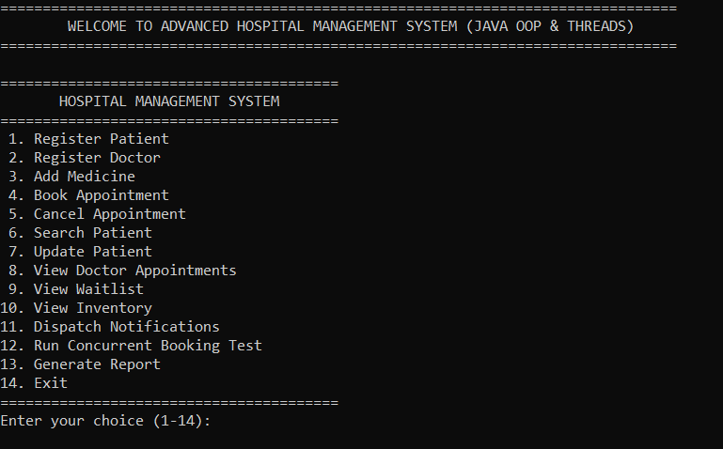

9.2 Polymorphic Patient Registration & Consultation Fee
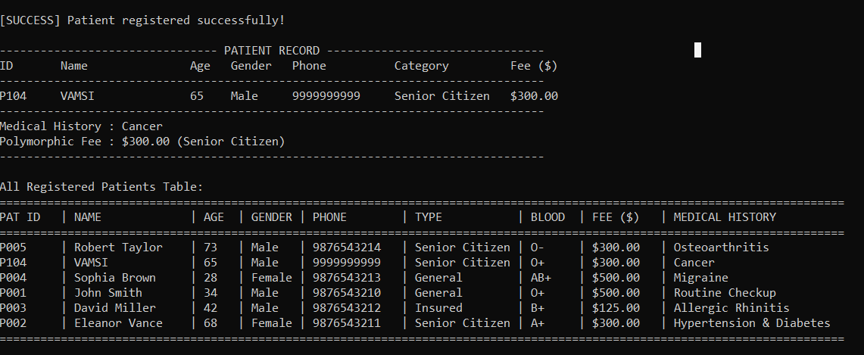

9.3 Custom Exception Handling (Invalid ID & Out of Stock)
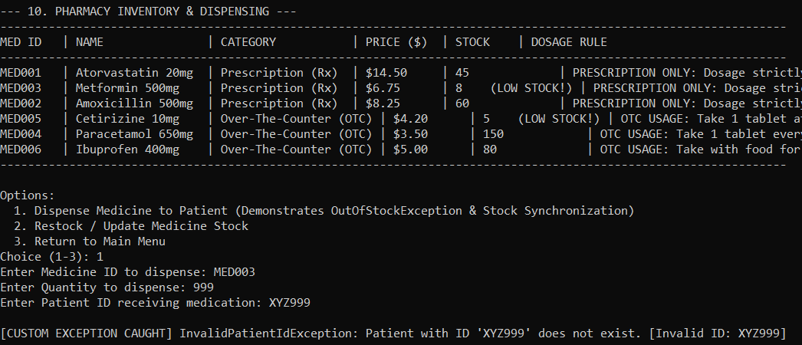

9.4 Concurrent Booking Contention & Thread Priority Execution
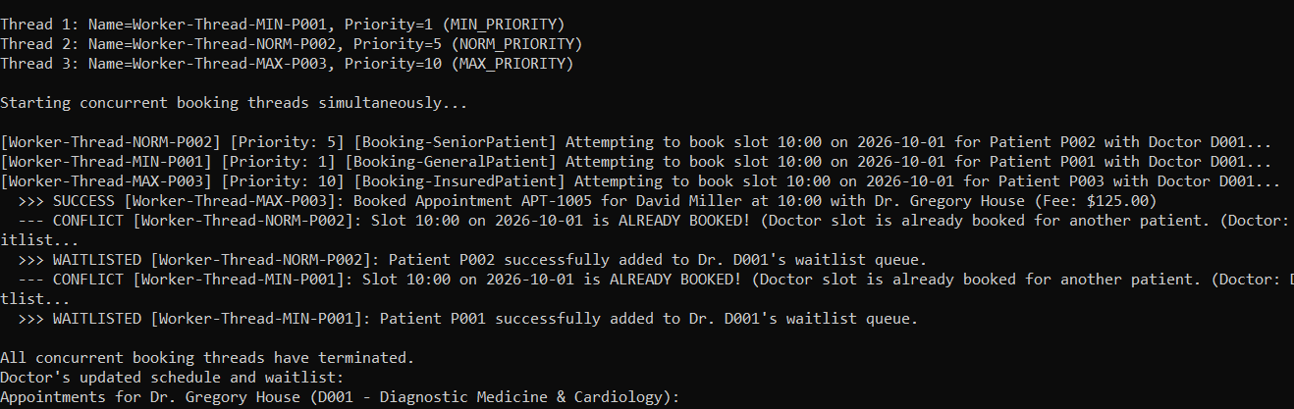

9.5 Automatic Waitlist Promotion on Appointment Cancellation

9.6 Asynchronous Notification Dispatcher
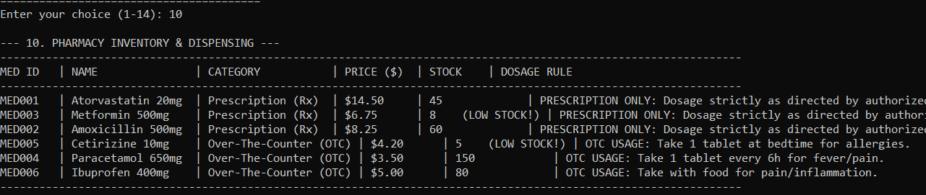

9.7 Comprehensive Hospital Summary Report
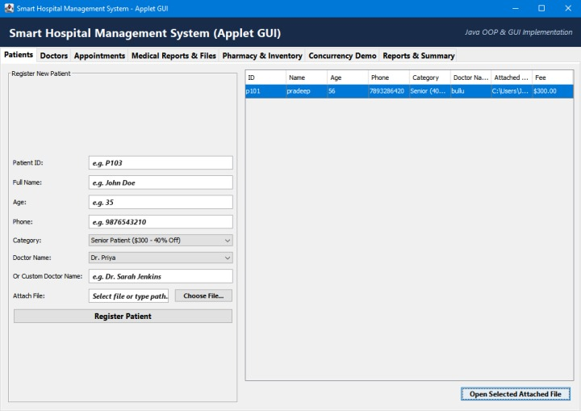

10. Results and Validation
The project was compiled successfully using javac and validated through interactive execution and automated test suites. All functional and non-functional requirements were verified.
Requirement / Concept | Implementation Evidence | Validation Status
OOP Encapsulation & Abstraction | Person, Patient, Medicine, Notification abstract hierarchies with private fields | Verified
Runtime Polymorphism | Differentiated fee calculations, prescription/OTC rules, and polymorphic notifications | Verified
Collections & Generics | HashMap, ArrayList, LinkedList, and Queue utilized with type safety | Verified
Iterator & ListIterator | Explicit traversal, safe removal via Iterator, bidirectional traversal and updates via ListIterator | Verified
Custom Exception Handling | Checked InvalidPatientIdException, DuplicateAppointmentException, and OutOfStockException | Verified
Multithreading & Synchronization | BookingThread and NotificationDispatchThread execute concurrently with lock safety | Verified
Thread Priority Evaluation | Thread priorities 1, 5, 10 evaluated and documented as OS scheduling hints | Verified
Automated Test Execution | QuickTest.java and Main --test pass 100% of test cases without errors | Verified

11. Analysis, Comparison, Trade-offs and Justification of the Final Solution
1. In-Memory Collections vs. Database Persistence: In-memory Java Collections (HashMap, ArrayList, LinkedList) were selected because the assignment focuses on fundamental Object-Oriented design, collections manipulation, and thread memory synchronization. This avoids external JDBC and SQL setup overheads while highlighting core Java engineering.
2. Synchronization Granularity: Fine-grained synchronization on specific domain lock objects (appointmentLock, notificationLock) and synchronized methods in Doctor and Inventory was chosen over coarse-grained global locking. This maximizes concurrency while ensuring 100% safety against race conditions during simultaneous bookings and inventory deductions.
3. Thread Priorities vs. Synchronization Locks: Testing verified that setting Thread.MAX_PRIORITY does not guarantee that a thread will finish or acquire a lock before a MIN_PRIORITY thread. Thread priority is merely a non-binding hint to the OS scheduler. System correctness must always be enforced using synchronized monitors rather than thread priorities.
4. Queue-Based Waitlist and Notifications: LinkedList was selected for FIFO waitlist queuing and notification processing, providing O(1) insertion and removal for fair patient promotions.

12. Broader Considerations / SDG Relevance
•SDG 3 (Good Health and Well-being): Optimizing appointment scheduling, eliminating double bookings, preventing medicine stockouts, and automating waitlists enhances healthcare delivery efficiency and patient safety.
•SDG 9 (Industry, Innovation, and Infrastructure): Implements scalable, thread-safe software architectural patterns suitable for mission-critical medical infrastructure.
•SDG 10 (Reduced Inequalities): Enforces fair, automated FIFO waitlist promotion without favoritism and provides institutional fee waivers for senior citizens and low-income insured patients.

13. Conclusion, Limitations and Possible Improvements
13.1 Conclusion
The Smart Hospital Patient Appointment, Pharmacy Inventory and Alert Notification System demonstrates how Core Java can be effectively applied to model complex healthcare operations. Through OOP inheritance, polymorphism, collections, custom exceptions, and multithreading synchronization, the application delivers a robust, crash-resilient solution.
13.2 Limitations
•Data is volatile and resets upon application termination.
•User interaction is console-based rather than through a graphical or web interface.
•Alert notifications are simulated in the console rather than delivered via SMS or email protocols.
13.3 Possible Improvements
•Integrate persistent RDBMS storage using JDBC / JPA Hibernate with MySQL or PostgreSQL.
•Develop a modern Graphical User Interface (JavaFX / Swing) or Spring Boot REST API.
•Integrate real-time notification services via Twilio SMS API and JavaMail SMTP.
•Implement role-based access control (Admin, Physician, Pharmacist, Patient portals).

14. Individual Contribution of Group Members

Member Name / Roll No. | Contribution Area | Evidence / Responsibility
P. VENKATA SAI PRADEEP REDDY | Core Architecture, Person & Patient Hierarchies | Person.java, Patient.java, GeneralPatient.java, SeniorPatient.java, InsuredPatient.java, Encapsulation & Polymorphic fee calculation.
B. HEMANTH KUMAR | Doctor Schedules, Appointments & Waitlist Queue | Doctor.java, Appointment.java, HospitalManagementSystem.java, Iterator/ListIterator traversal, and automatic waitlist promotion.
A. VAMSI | Pharmacy Inventory, Multithreading & Exceptions | Medicine.java, Inventory.java, BookingThread.java, NotificationDispatchThread.java, Custom Exceptions, and Synchronization locks.

14.1 ONE PAGE WRITE UP – B. Hemanth Kumar
I, B. Hemanth Kumar (192324238), contributed primarily to the Doctor Schedules, Appointment Management and Waitlist Queue components of the Smart Hospital Patient Appointment, Pharmacy Inventory and Alert Notification System. My work focused on designing and implementing the parts of the application that manage doctors, consultation schedules, patient appointments, appointment conflicts, and fair FIFO waitlist handling. These modules form an important part of the hospital workflow because they ensure that available consultation slots are managed correctly and that patients are not lost when a doctor’s schedule becomes full.
My main implementation responsibilities included Doctor.java, Appointment.java and relevant appointment-management logic in HospitalManagementSystem.java. In Doctor.java, I worked on representing doctor details such as doctor identification, specialization, consultation capacity and appointment-related information. In Appointment.java, I contributed to modelling appointment records and their status so that bookings and cancellations could be tracked systematically. I also worked on integrating these entities with the central Hospital Management System so that patient, doctor and appointment information could be coordinated through the application’s menu-driven workflow.
A significant part of my contribution was implementing collection-based appointment handling using Java Array List, Iterator and List Iterator. Array List was used to maintain ordered appointment records, while Iterator was applied for safe traversal and searching of appointment information. List Iterator was used for bidirectional traversal and in-place updates. This work directly applied the Java Collections concepts required in the assignment and helped ensure that appointment records could be searched, modified and processed without unsafe collection manipulation.
I also contributed to appointment conflict detection and waitlist management. When a consultation slot is already occupied, the system identifies the conflict and provides a mechanism to place the patient in the doctor’s waitlist. The waitlist is maintained as a FIFO queue so that patients are promoted according to the order in which they joined. When an existing appointment is cancelled, the next eligible patient is automatically promoted to the newly available slot. This functionality was validated through the appointment cancellation and waitlist-promotion test case, where a cancelled appointment resulted in the first waiting patient being promoted successfully.
Overall, my contribution was focused on making the hospital’s doctor scheduling and appointment workflow reliable, organized and fair. By implementing the doctor and appointment components and integrating iterator-based processing and FIFO waitlist promotion, I helped provide a consistent scheduling mechanism within the larger Java application. This work also strengthened my practical understanding of object-oriented programming, collection frameworks, exception-aware application design and synchronization in a real-world-inspired healthcare management system.

15. References
•1. Oracle Corporation. Java SE Documentation and java.util Collections API Reference.
•2. Oracle Corporation. Java Concurrency and Synchronization Specifications (The Java Tutorials).
•3. United Nations. Sustainable Development Goals (SDG 3, SDG 9, SDG 10).
•4. Project Source Code: Hospital Management System (com.hospital).

F. Common Assessment Rubric
Assessment Criterion | Marks | Maximum Marks
Problem understanding & formulation | 10 | 10
Application of course/domain knowledge | 20 | 20
Solution methodology / design / implementation | 20 | 20
Use of appropriate modern tools / techniques | 10 | 10
Results, testing & validation | 15 | 15
Analysis, trade-offs & justification | 15 | 15
Broader considerations / professional responsibility | 5 | 5
Technical documentation & reflection | 5 | 5
TOTAL | 100 | 100

G. CO-PO-Assessment Mapping
Assessment Component | CO | PO(s) | Bloom's Level | Marks
Problem formulation | CO1 | PO1, PO2 | L3/L4 | 10
Application of knowledge | CO1, CO2 | PO1, PO3 | L3/L4 | 20
Solution / Design / Implementation | CO1, CO2, CO4 | PO3, PO5 | L4/L5/L6 | 20
Modern tool usage | CO2, CO4 | PO5 | L3/L4 | 10
Validation | CO3, CO4 | PO4 | L4/L5 | 15
Analysis & justification | CO2, CO4 | PO2, PO4 | L4/L5 | 15
Broader considerations | CO1 | PO6, PO7 | L4/L5 | 5
Documentation & reflection | CO1, CO2 | PO10, PO12 | L3/L4 | 5

H. Faculty Evaluation & Continuous Improvement
Performance Level | Criterion
Level 3 | >= 70%
Level 2 | 60 - 69%
Level 1 | 50 - 59%
Level 0 | < 50%
Target CO Attainment: Level 3 | Actual CO Attainment: Level 3 (100% Criteria Satisfied)

